

**American International University- Bangladesh**

**Department of Computer Science**

**Assignment Cover Sheet**

|  |  |  |  |
| --- | --- | --- | --- |
| **Course Name** | Data Communication | | |
| **Assignment On** | Laboratory Task | **No.** | 7 |
| **Lecturer Name** | Md. Navid Bin Anwar | | |
| **Semester** | Summer 2019-20 | | |
| **Submission Date** | 26.8.20 | | |
| **Section** | F | | |
| **Group No.** | 6 | | |
|  |  |  | |
| **Student Name** | **Student ID** | **Contribution (out of 100%)** | |
|  | 18-37645-1 | 20% | |
|  | 18-37598-1 | 20% | |
|  | 18-37855-2 | 20% | |
|  | 18-37459-1 | 20% | |
|  | 18-37609-1 | 20% | |
| **Teacher Remarks**  (Only for teacher) |  | | |

Performance Task for Lab Report: (your ID = AB-CDEFG-H)

(a) Generate a function which will convert a text message into binary bit sequence.

(b) Generate the digital signal where the bit duration is 1 sec.

(c) Formulate the code in (a), so that it can perform asynchronous transmission (10 bits).

(d) Write necessary code so that it will ask the users whether to perform synchronous/asynchronous transmission and then perform accordingly (a, b).

(a)

Code:

function dn= as2bn(txt)

dec=double(txt)

p2=2.^(0:-1:-7);

B=mod(floor(p2'*dec),2);

dn=reshape(B,1,numel(B));

end

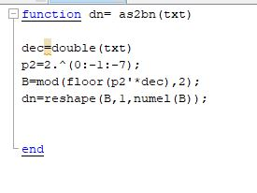

(b)

Code:

x= as2bn('Ras');

bp=1;

bit=[]

for n=1:1:length(x)

if x(n)==1;

se=ones(1,100);

else x(n)==0;

se=zeros(1,100);

end

bit=[bit se];

end

t1=bp/100:bp/100:100*length(x)*(bp/100);

subplot(1,1,1);

plot(t1,bit,'linewidth',2.5);

grid on;

ylabel('amplitude(volt)');

xlabel('time(sec)');

title('transmitting information as digital signal');

b=bin2asc(x)

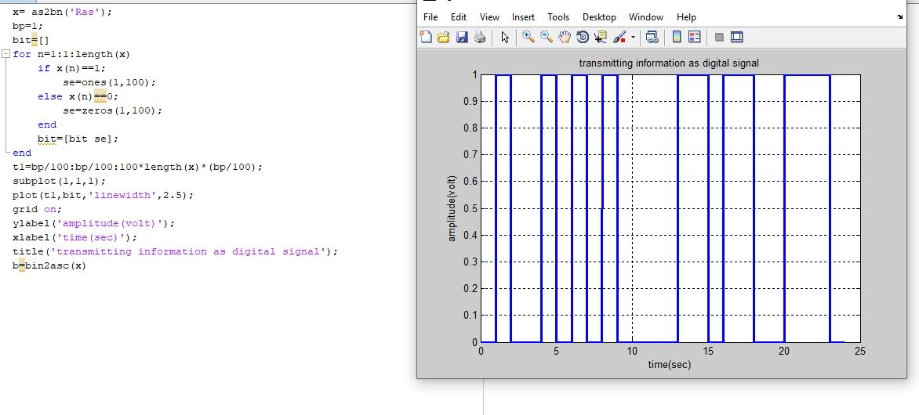

(c)

Code:

function dn= as2bnSYN(txt)

dec=double(txt)

p2=2.^(0:-1:-7);

B=mod(floor(p2'*dec),2);

c=size(B,2);

a=ones(1,c);

b=zeros(1,c);

A=[a;B;b];

dn=reshape(A,1,numel(A));

end

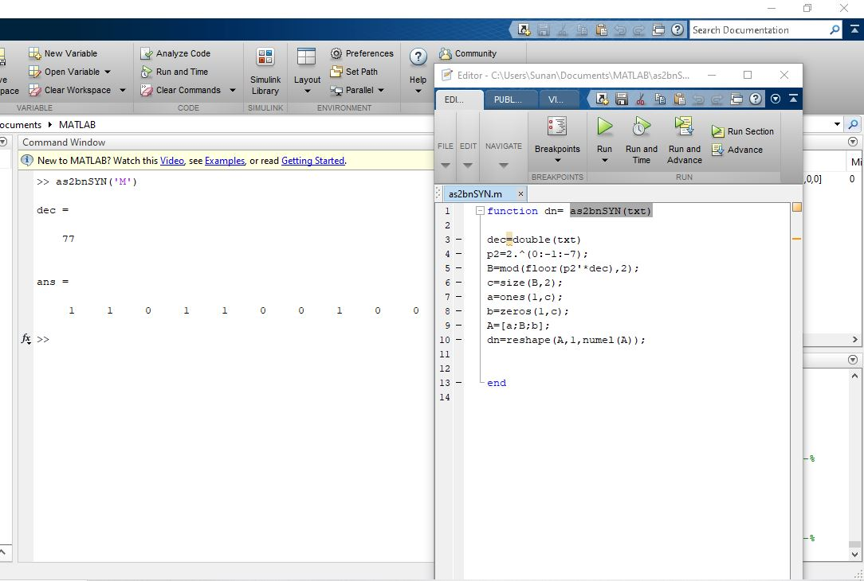

(d)

Code:

transmission = input(' prompt ', 's')

message= input(' prompt ', 's')

if (transmission=='S');

as2bn(message) %Function of syncronous transmission

else (transmission=='A');

as2bnSYN(message) %Function of asyncronous transmission

end

